**SET 02**

NAME: Shrawani Gaikwad

PRN: 2124UDSF1065

Q1.)Write an ansible playbook to install and start the apache 2 web server on managed node.

Expected Output apache 2 installed service running and accssed via browser

OUTPUT:

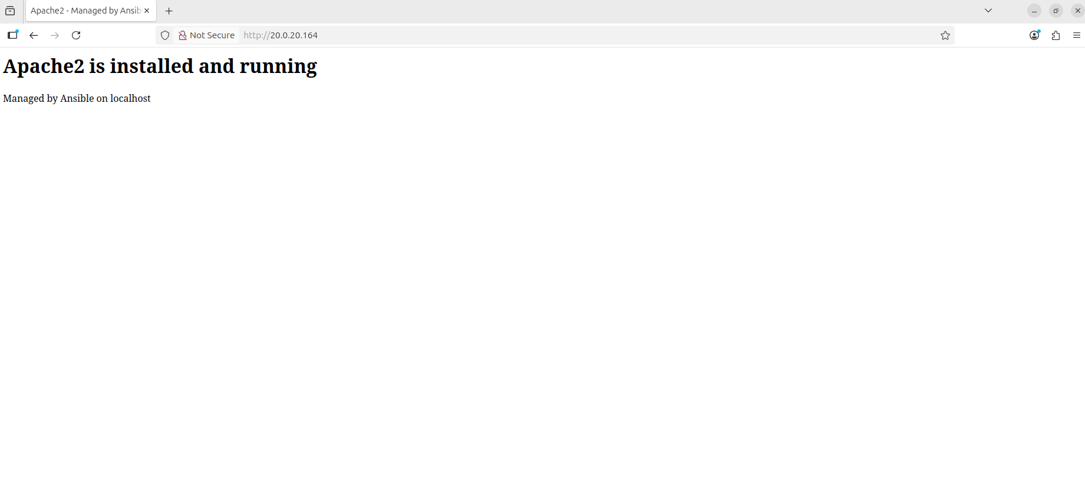

Q2.)Write docker file build image and push it to docker hub from command line.

Expected Output imag succesfully pushed to docker hub.

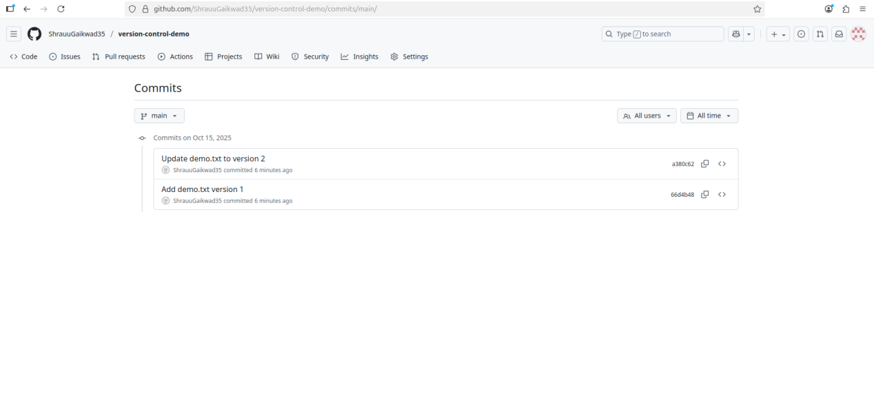

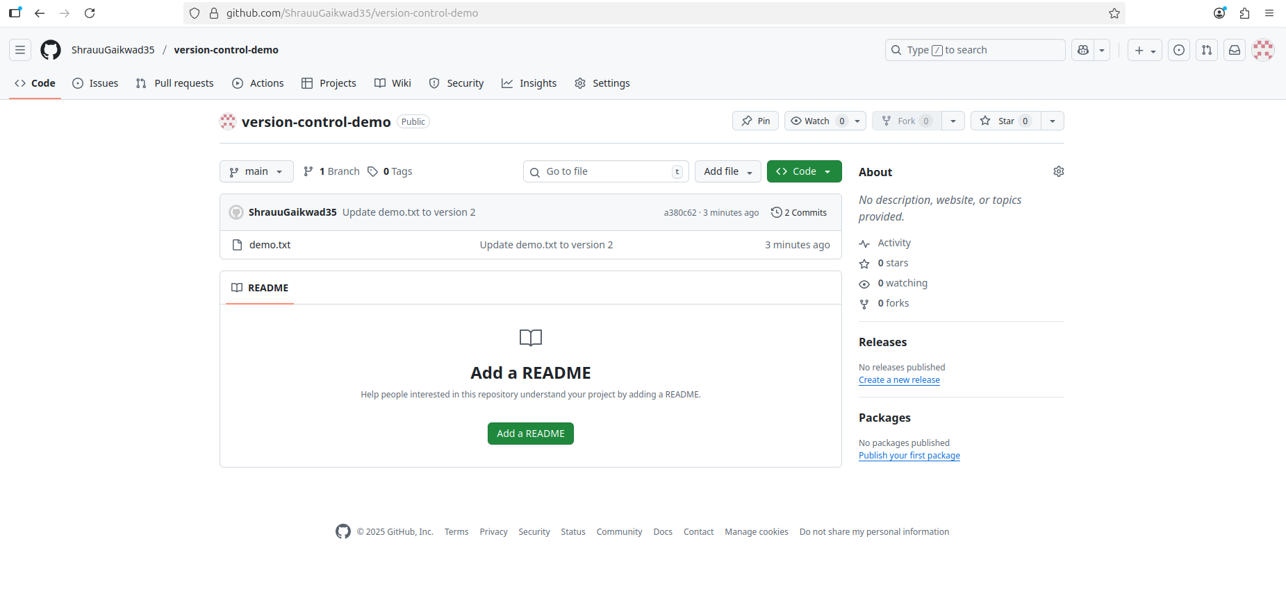

Q3.)Create a simple git repository commit and push at least two versions of same file showng version control in github.

